There was this question that resonated in my mind, just recently, as we began the 8 days of the Chanukah celebration, on the 12th of December of 2018. I was not sure we could have any real answers. First here was the question that came up. On the interesting question of whether the original Maccabees were Zadokites, here are some thoughts.....the following was my initial response given during the first few days of Chanukah.

A thought; while we don’t know for sure if the Maccabees were Zadokite priests, we know they were Tzadikim..RIGHT, UPRIGHT ONES; also if they were not Zadokites but a mere zealous tribe/family of “priestly wannabees”, wouldn't they be just as evil as the Greeks, as they willfully and KNOWINGLY replaced the Greeks with a false priesthood from the get go, perhaps to merely assume power? If that was true, how can they be called Tzadimim-upright ones? They would have been liars and deceivers, if they entered The Temple authority by falsehood and craftiness. Isn't it more probable that they were an exiled tribe that started a small community of fighters in the village of Moden, like Qumran, that left the Temple and already lived separate due to the Temple’s false priesthood and other subsequent Greek abominations? After all, they knew that Ezra had restored the Zadokites after Babylon, he himself being one! So why would they restore a priesthood that didn't emanate from Ezra? Ezra 7:1-2-“Now after these things, in the reign of Artaxerxes king of Persia, Ezra the son of Seraiah, the son of Azariah, the son of Hilkiah, the son of Shallum, the son of Zadok, the son of Ahitub.”

If that was the case, to me at least, they would have continued the defilement albeit in a different manner rather than cleansed it. See what I mean? I know we don't know for sure. But logically speaking this makes sense.

Then during our New Month-Chanukah service [12-19-18], we read large parts of the Books of the Maccabees. As we read it out loud publicly in the assembly, there it was! The answers that we had been looking for, was right there recorded in plain sight. First I want to give you the positive proof of the established fact that Mattityahu-Mattathias and his sons were indeed Zadokites according to bloodline. Then I want to share with you other waves of revelation and understanding that The Abba gave me since last night and that will be outlined in a short list below.

In First Maccabees Chapter 2 verse 1 we read:

1 About then, Mattathias son of John, son of Simeon, a priest of the line of Joarib-Yahoyariv, left Jerusalem and settled in Modein. If we look at the priestly order of Temple service, we notice in First Chronicles Ch. 24:7 that Joarib-Yahoyariv was the first of the 24 priestly courses! Amazingly, when both temples were destroyed on the 9th day of the 5th solar month, known today as Tisha BÁv, the priestly course of Joarib-Yahoyariv was serving at the altar on the Shabbats, when those 2 events occurred some 500 years apart. The only time that that priestly order of Joarib served on a weekly Shabbat, was in year 3 of a 6 year priestly cycle. In the chart below you can see that Joarib-Yahoyariv took their position at the altar on Shabbat the 9th day of Solar Month # 5 and served for the entire week, starting the 10th of the 5th month!

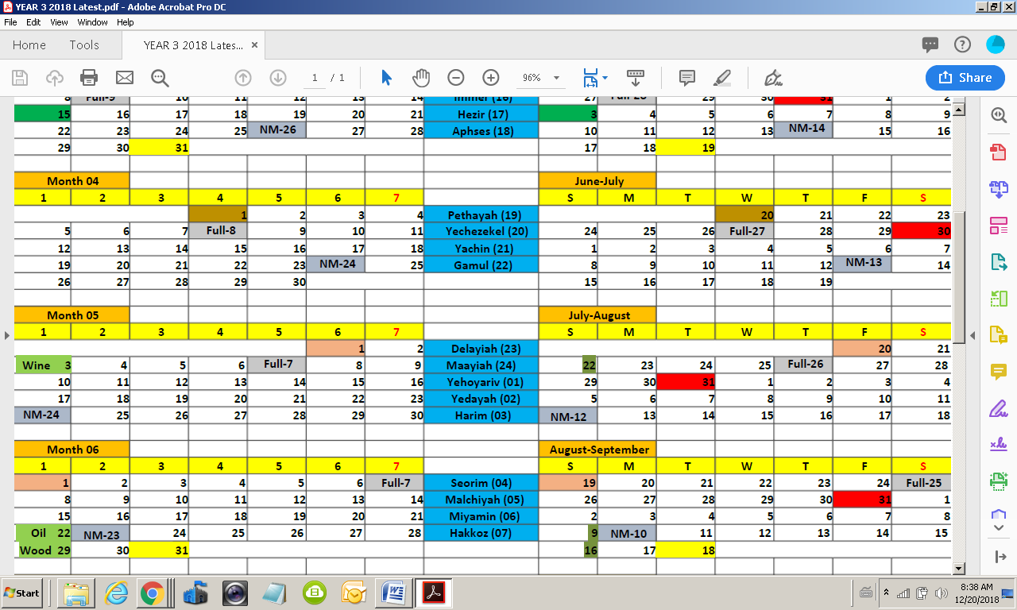

So the order of Joarib-Yahoyariv was at the altar when both Temples were destroyed, in 580 BC and again in 70 AD! How amazing, to see that his descendants the Maccabees, were charged in rebuilding the Temple altar in about December [Month 9] of 164 BC! The original Maccabees were direct descendants of the Zadokite priestly family of Joarib!
Then later in First Maccabees chapter 1, in verse 26 we read, “in his zeal for The Torah, he [Mattityahu] acted as Pinchus-Phinehas had against Zimri son of Salu”. Pinchus-Phinehas was a son of Kohath, grandson to Aaron the first Levitical High Priest, the true priestly lineage that would become The Zadokites in the time of King David & the First Temple in Solomon’s reign. In 1st Maccabees 2:54 we further read:

“Phineas-Pinchus our father in being zealous and fervent obtained the covenant of an everlasting priesthood.” That means that Kohath’s seed through Zadok will ALWAYS HAVE THE PREISTHOOD IN ISRAEL and that in order to be legitimate sons of Kohath, Aaron, Eliezer, Pinchus and Zadok through Joarib, it had to be an established undisputed matter of fact and public temple record, which we now see it was! One thing is now settled. The Maccabees were not a nice Jewish family that decided to wage war on the Greeks because they were faithful to the rabbis or rabbinical leadership or mere Jewish culture. They were not mere cultural warriors as many portray them today!
They were not part of what later would evolve into the Pharisees and the Sadducees, themselves illegal occupants of the priesthood. In order to blur the matter even further, the Sadducees called themselves Zadokim, meaning the true Zadokites. We know this was a lie and deception, because they were not the descendants of Zadok and their belief system betrayed their underhandedness. They rejected the everlasting covenant of Pinchus, rejected all Scripture books other than just the 5 Books of Moses, along with denying the supernatural and the resurrection from the dead, along with denying all angelic activity as authentic. So yes dear friends. THE MACCABEES WERE IN FACT ACTING IN ACCORDANCE WITH HEAVEN AND WITH ALMIGHTY YHUH, RAISED UP TO DO HIS WILL! They were not Jewish or rabbinic culture warriors! They were not fictional superheroes! Now, on to a few more interesting questions and answers.

Why do Christians reject the Books of the Maccabees?

Answer: Because it points believers in Elohim YHUH to keep and obey The Torah and calls an end to defilement of the Shabbat and other Torah required institutions, which Messiah and His apostles themselves observed. In order to continue to claim that only Jews have to keep the Torah, they have removed it from their bibles, although initially it was part of the 1611 King James Version. It simply was too Hebraic and conflicted with their antinomian-anti-Torah doctrines and lies! Another reason is they blindly followed the Jews incorrectly trusting them, in regards to what may or not be Scripture, as seen in the translations of anti-Yahusha rabbinic redactions, which they simply accepted, figuring the Jewish Masorites, would know what they are saying and never dare to change or alter Scripture. Sadly, the Masorites did change Scripture and Christians merely trusted their integrity. Bad move to say the least!

Why do the rabbis or rabbinical leaders not include The Books of the Maccabees in the Tanach-Older Testament?

Answer: First and foremost, it delegitimizes their claim to have replaced the Zadokite priests, as the true spiritual leaders of Israel. In order to continue to sit in Moses Seat and mislead the Jewish people away from truth and Adon Yahusha The Messiah, they must eliminate and obfuscate all books that teach Israel, that the Zadokites and Zadokites alone, are charged with overseeing the affairs of Israel in all things spiritual. By removing Maccabees, they make it difficult for anyone to challenge their authority, as also seen in their removal and or denial of the Book of Enoch and other such books. The Books of the Maccabees are a direct threat to their stranglehold on the Jewish nation. They blame the corrupt Hasmoneans that came after Judah and his brothers, as being in league with Rome and being corrupt. That is all true; however it cannot and does not negate the original calling and set apart righteous behavior by Mattityhau and his sons. The rabbis conveniently used the latter corruption, to deny the Zadokite pedigree that the Maccabees originally had!

Obviously our Adon MarYah Yahusha had no issues with these books being inspired or the original Maccabees as being righteous and zealous, as can be seen by His personal observance and celebration of the Feast of Rededication found in John chapter 10. As an interesting side note, Zachariah the father of John The Baptist, was a Zadokite as witnessed by the angelic affirmation, as he served at the Temple altar in the Zadokite priestly course of Abiyah, the 8th course. Luke 1:5; First Chronicles 24:10. Elizabeth his wife, was also from the House of Aaron. That would make his son John The Baptist a Zadokite, as well, as his cousin Messiah Yahusha! Yahusha had both Zadokite-Levite tribal affiliation, as well as that from Judah. Although, these were His mere tribal families, for in reality, He had no human dust DNA, being the Master from above!

Now to some 10 million dollar questions!

Why were there no copies of Maccabees found at Qumran in the Dead Sea Scrolls?

Answer: We are not sure they didn’t have copies. It is possible they simply were never found and are in some other caves and may be unearthed one day soon.

If the Qumran community was also a breakaway Zadokite sect in exile from Jerusalem, why were no records from the Maccabees found? Wouldn’t they be in one accord with the Maccabees?

Answer: Not really, or necessarily. First off, each of these Zadokite communities was independently overseen and as such differed in doctrine and structure. For example, the Zadokite sect in Qumran were pacifists, the Maccabees fighters! The Qumran sect may not have agreed with any Zadokite sect that promoted open warfare and hostility against the enemies of Israel. In addition, we know that the Maccabees had families, perhaps plural wives and children, whereas the group at Qumran, saw marriage and children as a stumbling block to serving YHUH and rather discouraged it and MISTAKENLY called polygyny an abomination. They preferred to adopt orphans and attend to widows.

There were many other differences, such as defending yourself on the Shabbat from enemy attack. The Maccabees purposed to defend themselves on Shabbat and holy days, while the sect at Qumran would not. Last but not least, when the Maccabees were righteous around 164 BC, all was well. However history tells us that within a generation or two, the Hasmoneans became an extension of Rome and sold offices to the highest bidder and placed people in power and the priesthood, that were not sons of Zadok. By the time the Qumran community flourished, some perhaps 50 years or so later, their concept and view of the Maccabees was tainted by their later corruption, that they had allowed and by the corrupt leaders they had become. People and even believers that reject Chanukah and the Maccabees, continue to use that as a pitiful excuse, to avoid its observance, to their own shame and disgrace!

The Qumran Zadokite community and perhaps later Jews began to view the Maccabees with hate and contempt, as what started out as a righteous movement had evolved into outright corruption and abominations. Perhaps, these and other yet unknown reasons, all account for a Qumran rejection of the Books of The Maccabees. Nevertheless, if we focus only on Matthias and his sons, we can see that they were legitimate Zadokites, in their own generation and their records were and remain pure and inspired. We need not throw out the truth, that heaven approved of and sealed, simply because of bad apples a generation or two later. That would simply compound previous errors of rejecting these books, which in my view must be restored to Scripture.
Epilogue-Does Josephus the historian weigh in? Yes, he himself claimed to be a descendant of Jonathan, Judah’s brother, thereby making Josephus a real Zadokite priest as well, who later married into the House of Rome, forbidden in Torah.

At the time of the revolt against Rome, however, the prominent descendants of the Maccabees were not counted among the rebels [against Rome]. Agrippa II, the great-grandson of Herod and Mariamne, the last Hasmonean princess, was cooperative with Rome and ineffectual during the war against Rome.

Josephus himself, who eventually assisted Rome, distantly traced his ancestry back to Judah Maccabee’s brother Jonathan.

