The Seat of S.a.tan. Where Was It? Where Is It Now? Why It Must Be Restored.
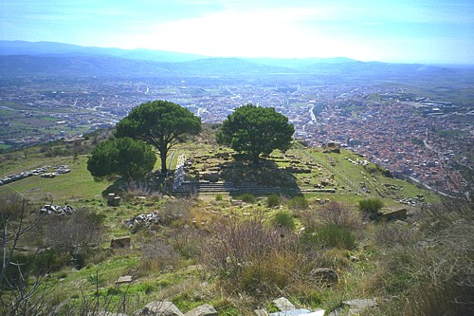Pergamum: Altar to Zeus
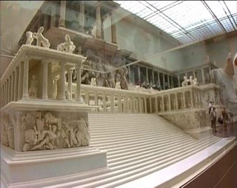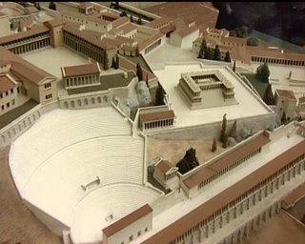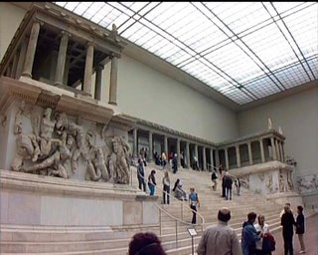
Above-S.A.TAN’S SEAT AS IT APPEARED IN 90 C.E. IN THE TIME OF THE APOSTLES/SHLICHIM
Gates of Babylon/Ishtar (Pictured Below)
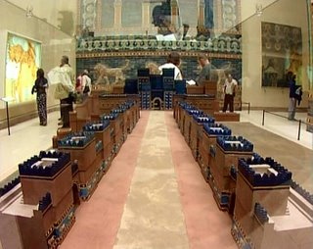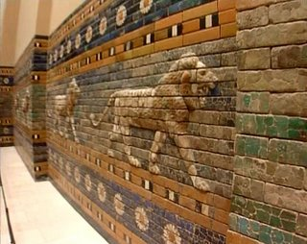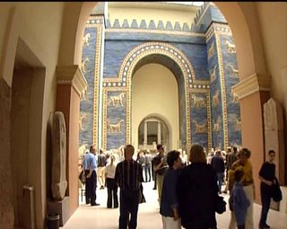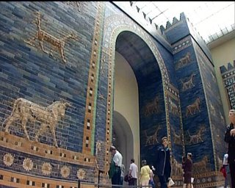
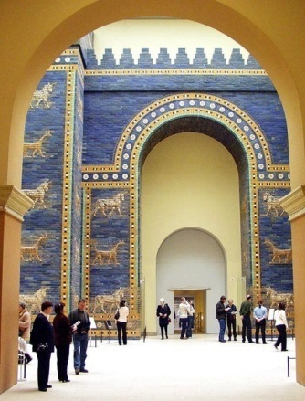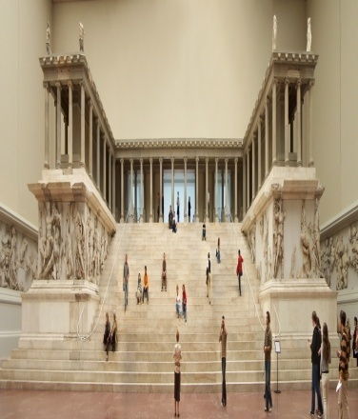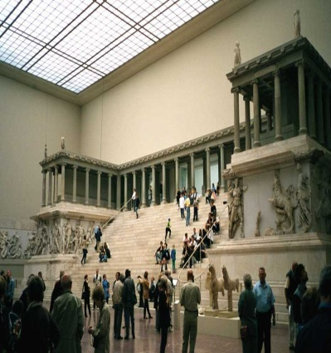
Above-While the actual edifices of the gates and the seat may be in Berlin for now, the SPIRITUAL CENTER REMAINS IN TURKEY, as the spirit realm lives there as before.
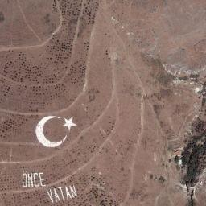
The area of s.a.tan’s seat marked today with Daniel’s little horn, and the words Once Vatan meaning one community or nation of Islam. This is the only place in Islam where a place is marked like this into the actual hill.

