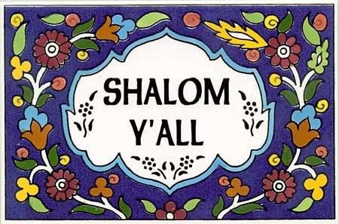
Our Community in the Macclenny Florida Area. ﻿The Nazarene Yisraelite Community @ Goshen BeTzafon. Introducing B'nai Yahushua Congregation of Baker County Florida!
- Tired of church buildings and the traditions of men?
- Did you know that the Name of God is not God or Jehovah?
- Want to worship Yahushua-Jesus in His original Hebraic faith?
- Want to have faith in Yahushua-Jesus and also the very faith of Yahushua-Jesus?
- Do you want to observe the Sabbath on the 7th day like our Savior-Luke 4:16?
- Have you ever questioned the manmade religious traditions based on tradition & paganism?
- Would you like to celebrate the times and holy days of Scripture, rather than the holidays of man? Want to learn how to eat clean foods like outlined in Scripture?
Scripture is clear. Most of mankind including born again folks are deceived and have accepted the traditions of men, which in most cases have replaced the Word of YHWH-God. Mark 7:6-8.
Scripture warns us to make sure we understand the Word in its original Hebraic contact in which it was sown. Matthew 13:9.
Has anyone ever taught you that all born again believers in Yahushua-Jesus are part of the spiritual and physical commonwealth of Israel-Ephesians 2:19? Well Scripture says you are an Israelite. Has anyone ever told you that all Jews are Israelites but MOST Israelites are not Jews? Want to learn with us? From house to house, like the first century disciples without the expensive church buildings?
Phone 1-904-800-7321 For More Spiritual help and information. We will make a time to meet and share the Good News of Messiah and Israelite living!
Website: http://www.yourarmstoisraelglobal.com/
Office E Mail: info@yourarmstoisraelglobal.com
General Overseer: Sholiach Moshe Yoseph Koniuchowsky
PO BOX 1427
MACCLENNY, FL. 32063

